**MODULE: 1**

**SE – Overview of IT Industry**

1. **What is software? What is software engineering?**

**Ans. :**

* In simple terms, software refers to the programs, data, and instructions that make computers and other devices work. It's the intangible part of a computer system that you can't touch.
* software engineering is like the wizardry behind creating and maintaining software. It involves designing, coding, testing, and maintaining software systems. Think of it as the art and science of turning ideas into functional and reliable software. It's like building a digital masterpiece!

1. **Explain types of software.**

**Ans. :**

* **Application Software** : Software that performs special functions or provides functions that are much more than the basic operation of the computer is known as [application software](https://www.geeksforgeeks.org/what-is-application-software/).

**Ex**: Microsoft Office, Paint, PowerPoint, etc.

* **System Software**: [System software](https://www.geeksforgeeks.org/system-software/)is software that directly operates the [computer hardware](https://www.geeksforgeeks.org/computer-hardware/) and provides the basic functionality to the users as well as to the other software to operate smoothly.

**Ex**: Notepad, Calculator, etc.

* **Driver Software**: A driver in software provides a programming interface to control and manage specific lower-level interfaces that are often linked to a specific type of hardware, or other low-level service.

**Ex**: Audio driver, Video driver, etc.

* **Middleware**: Middleware is software that lies between an operating system and the applications running on it. Essentially functioning as hidden translation layer, middleware enables communication and data management for distributed applications.

**Ex**: Database middleware, application server

* **Programming Software**: Programming software is a [software](http://www.defit.org/?p=106) which helps the programmer in developing other software.

**Ex**: Turbo c, Eclipse, Subline, etc.

1. **What is SDLC? Explain each phase of SDLC.**

**Ans. :** SDLC stands for Software Development Life Cycle, which is a process used by software developers to design, develop, test, and deploy high-quality software systems.

1. **Planning :** The planning phase typically includes tasks like cost-benefit analysis, scheduling, resource estimation, and allocation. The development team collects requirements from several stakeholders such as customers, internal and external experts, and managers to create a software requirement specification document.
2. **Analysis:** In the Analysis phase, software engineers analyse requirements and identify the best solutions to create the software.
3. **Design:** In the design phase, software engineers analyse requirements and identify the best solutions to create the software. For example, they may consider integrating pre-existing modules, make technology choices, and identify development tools. They will look at how to best integrate the new software into any existing IT infrastructure the organization may have.
4. **Implementation:** In the implementation phase, the development team codes the product. They analyse the requirements to identify smaller coding tasks they can do daily to achieve the final result.
5. **Testing & Integration:** The development team combines automation and manual testing to check the software for bugs. Quality analysis includes testing the software for errors and checking if it meets customer requirements. Because many teams immediately test the code they write, the testing phase often runs parallel to the development phase.
6. **Maintenance:** In the maintenance phase, among other tasks, the team fixes bugs, resolves customer issues, and manages software changes. In addition, the team monitors overall system performance, security, and user experience to identify new ways to improve the existing software.
7. **What is DFD? Create a DFD diagram on Flipkart.**

**Ans. :** A data flow diagram (DFD) is a graphical or visual representation using a standardized set of symbols and notations to describe a business's operations through data movement.

**DFD diagram on Flipkart.**

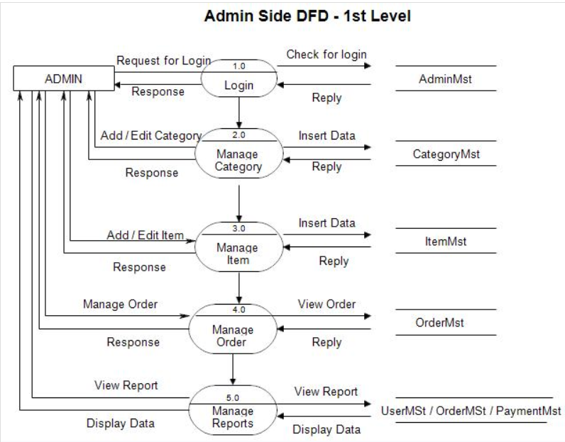

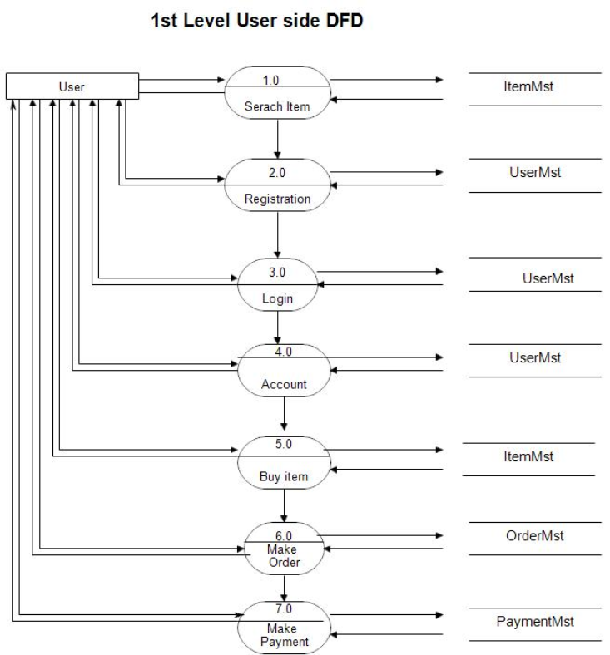

1. **What is Flow chart? Create a flowchart to make addition of two numbers**

**Ans. :** A flowchart is a picture of the separate steps of a process in sequential order. It is a generic tool that can be adapted for a wide variety of purposes, and can be used to describe various processes, such as a manufacturing process, an administrative or service process, or a project plan.

**Flowchart to make addition of two numbers**

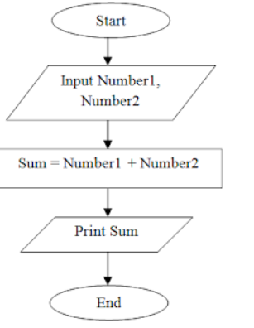

1. **What is Use case Diagram? Create a use-case on bill payment on Paytm.**

**Ans. :** A use case diagram is a visual representation of the functional requirements of a system, showcasing how users interact with it. It typically includes actors (users or external systems) and use cases (specific functionalities or tasks).

**a use-case on bill payment on Paytm.**

